Tiffany Wang

260684152

ECSE 543 – Assignment 3

TABLE OF CONTENT

Question 1 2

Table 1. BH Data for M19 Steel 2

a) Interpolate the first six points using full-domain Lagrange polynomials. 2

Figure 1. Approximated H-field using Lagrange Polynomials Interpolation part a 3

Figure 2. H vs B approximation using full-domain Lagrange Polynomial (first six points) 3

b) Interpolate [0, 1.3, 1.4, 1.7, 1.7, 1.8] using full-domain Lagrange Polynomial 4

Figure 3. Approximated H-field using Lagrange Polynomials Interpolation part b 4

Figure 4. B vs H approximation using full-domain Lagrange Polynomial (specific points) 4

c) Cubic Hermite polynomial interpolation 5

Figure 5. Results from the Approximation using cubic Hermite polynomials 5

Figure 6. B vs H approximation using Cubic Hermite Polynomials 6

Question 2 6

Figure 7. Icon core with magnetic flux 6

a) Derive a (nonlinear) equation for the flux in the core 7

Figure 8. Equivalent circuit to the iron core 7

b) Solve the flux nonlinear equation using Newton-Raphson 8

Figure 9. Results from nonlinear Newton-Raphson approximation 8

c) Solve the problem with successive substitution. 8

Figure 10. Results from nonlinear Successive Substitution approximation 8

Question 3 8

Figure 11. Circuit of the analyzed nonlinear circuit 8

a) Derivation of the nonlinear equations for the nodal voltages [V2, V1] 9

b) Solve nodal voltage equations using Newton-Raphson 9

Figure 12. Records of *f* and *Vn* during Newton-Raphson 10

Figure 13. Error trend in the Newton-Raphson approximation 10

Question 4 11

a) Integrate cos(x) over x = 0 to x = 1 using one-point Gauss-Legendre integration 11

Figure 14. Integration result and error of cos(x) using N equal segments with one-point Gauss-Legendre 11

Figure 15. Graph Log(E) vs. Log(N) of the one-point Gauss-Legendre for cos(x) 11

b) Integrate ln(x) over x = 0 to x = 1 using one-point Gauss-Legendre integration 12

Figure 16. Integration result and error of ln(x) using N equal segments with one-point Gauss-Legendre 12

Figure 17. Graph Log(E) vs. Log(N) of the one-point Gauss-Legendre for ln(x) 12

c) Non-Uniform segmentation for one-point Gauss-Legendre integration 13

Figure 18. Result of Non Uniform segmenting one-point Gauss-Legendre integration 13

Table 2. Comparison between uniform and non-uniform segmenting integration 13

*APPENDIX* 14

# Question 1

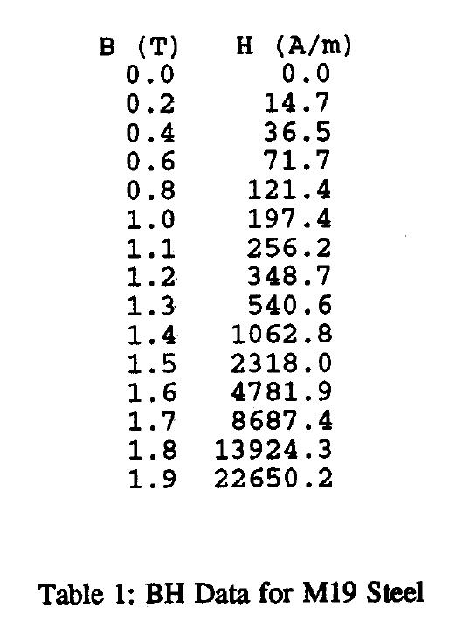

Table 1. BH Data for M19 Steel

## Interpolate the first six points using full-domain Lagrange polynomials.

The Lagrange polynomials coefficients are found using:

Then, the approximated value of H is found using

The approximated H-field from B = 0.0, 0.01, 0.02 … 0.99, 100 is the following:

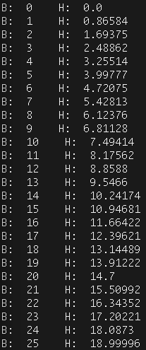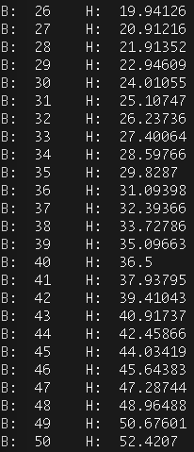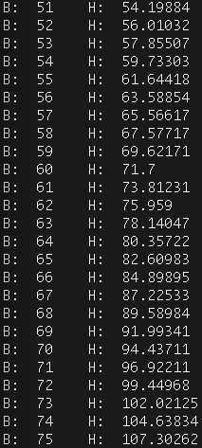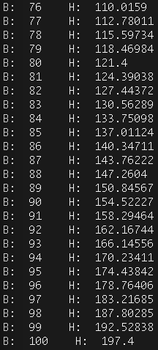

Figure 1. Approximated H-field using Lagrange Polynomials Interpolation part a

Figure 2. H vs B approximation using full-domain Lagrange Polynomial (first six points)

The graph is really smooth. There are no sharp turns, and the function’s behavior is consistent (monotonically increasing). Therefore, we can assume that this interpolation is plausible.

## Interpolate [0, 1.3, 1.4, 1.7, 1.7, 1.8] using full-domain Lagrange Polynomial

The Lagrange Polynomial coefficients and the final approximation are found using the same formula as in part a.

The obtained results are

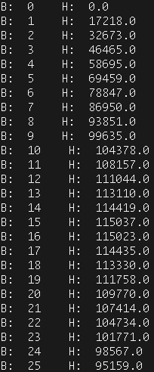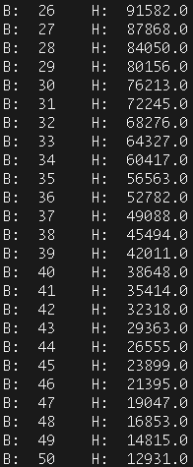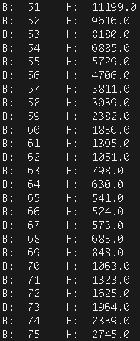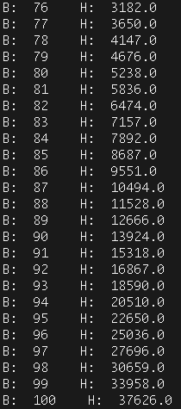

Figure 3. Approximated H-field using Lagrange Polynomials Interpolation part b

Figure 4. B vs H approximation using full-domain Lagrange Polynomial (specific points)

The shape of the graph does not represent a standard BH graph (i.e. the one found in part a). The result of this interpolation is not plausible.

## Cubic Hermite polynomial interpolation

We are going to interpolation the six points provided in part b, however using the cubic hermite polynomial method.

Finally, the approximation answer is found using:

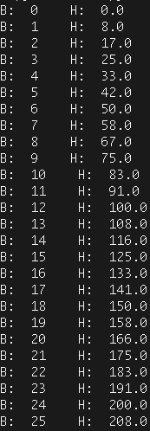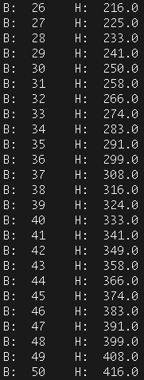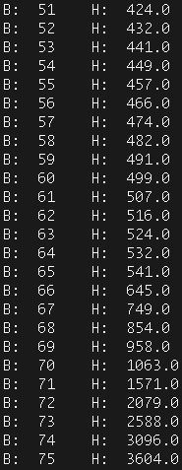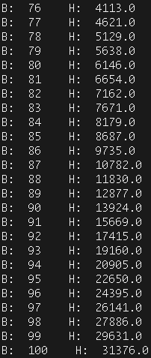

Figure 5. Results from the Approximation using cubic Hermite polynomials

Figure 6. B vs H approximation using Cubic Hermite Polynomials

The curve is a lot smoother, and there is not squiggling. Therefore, we can say that the cubic Hermite’s approximation result is plausible and it matches the original function.

In order to obtain a smoother curve, hence a better interpolation of the points, we can force the slopes of the functions to be continuous at the intersection of the subdomains.

We would have:

# Question 2

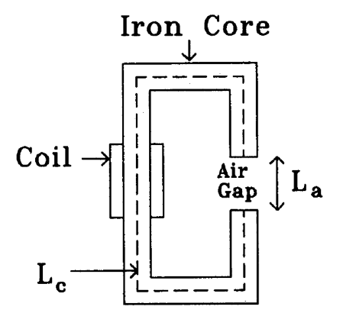

N = 1000

A = 1 cm2

Lc = 30 cm

La = 0.5cm

I = 8A

Figure 7. Icon core with magnetic flux

## Derive a (nonlinear) equation for the flux in the core

The equivalent impedance from a magnetic flux travelling through is

The iron core is equivalent to the following circuit:

../../../../../../Desktop/Screen%20Shot%202017-12-06%20at%201.02.37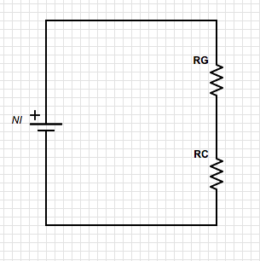

Figure 8. Equivalent circuit to the iron core

Where

RG: equivalent impedance in the air gap

RC: equivalent impedance in the core

NI: equivalent voltage source produced by the coil winding

: equivalent current flowing through the circuit

By KVL, this circuit must satisfy:

## Solve the flux nonlinear equation using Newton-Raphson

With the original guess of = 0V and , where *H’* is the derivative obtained from Table 1, we solve for in

until

../../../../../../Desktop/Screen%20Shot%202017-12-06%20at%201.19.38

Figure 9. Results from nonlinear Newton-Raphson approximation

## Solve the problem with successive substitution.

*H* is a function of , since

Therefore, the equation can be rewritten as

Our goal is to solve for until

At first the method throws a Divide by Zero error. Yet if you change the initial guess to a very small number, the method converges.

With

../../../../../../Desktop/Screen%20Shot%202017-12-06%20at%2012.03.29

Figure 10. Results from nonlinear Successive Substitution approximation

# Question 3

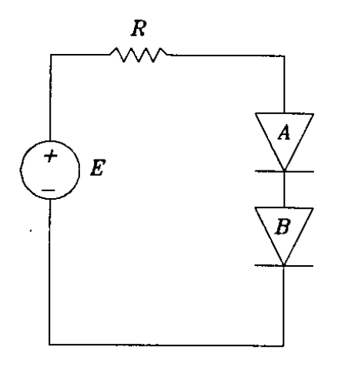

V1

V2

*ISA* = 0.6µA

*I­SB* = 1.2µA

*kT/q* = 25mV

*E*= 220mW

*R*=500Ω

Figure 11. Circuit of the analyzed nonlinear circuit

## Derivation of the nonlinear equations for the nodal voltages [*V2, V1*]

By KVL we have

We know that the current following through both diodes are the same. Therefore, we can set our second equation to be

## Solve nodal voltage equations using Newton-Raphson

We need the Jacobian matrix for Newton-Raphson

We want to use a similar approach as for Question 2, part b to solve for the nodal voltages of this problem.

The results of the Newton-Raphson approximation are

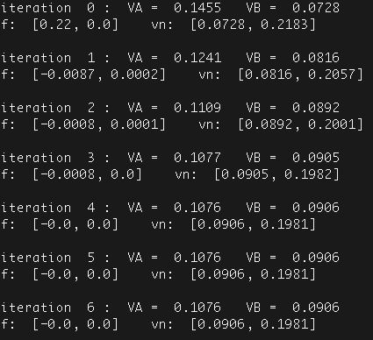

Figure 12. Records of *f* and *V­­n* during Newton-Raphson

The final voltage across Diode A is 107.6 mV and Diode B is 90.6mV

Figure 13. Error trend in the Newton-Raphson approximation

The best fitting trend line to this curve is a quadratic function. Therefore, we can conclude that the convergence is quadratic.

# Question 4

## Integrate cos(x) over x = 0 to x = 1 using one-point Gauss-Legendre integration

The answer of

We know that for one-point Gauss-Legendre, we have constants:

*wi = 2*

*xi = 0*

We are going to use these constants to solves the integration.

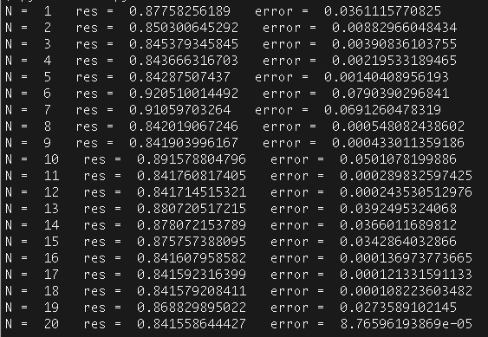

Figure 14. Integration result and error of cos(x) using N equal segments with one-point Gauss-Legendre

Figure 15. Graph Log(E) vs. Log(N) of the one-point Gauss-Legendre for cos(x)

The logarithmic error decreases in a linearly manner, with a few misplaced points. This means that while increasing the number of segments help with reducing the error, it is not always the case. Certain partitions are not beneficial than others.

## Integrate ln(x) over x = 0 to x = 1 using one-point Gauss-Legendre integration

The answer of

We know that for one-point Gauss-Legendre, we have constants:

*wi = 2*

*xi = 0*

We are going to use these constants to solves the integration.

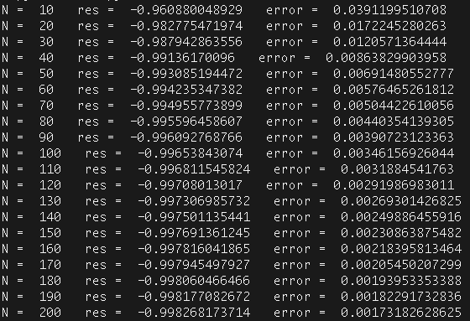

Figure 16. Integration result and error of ln(x) using N equal segments with one-point Gauss-Legendre

Figure 17. Graph Log(E) vs. Log(N) of the one-point Gauss-Legendre for ln(x)

## Non-Uniform segmentation for one-point Gauss-Legendre integration

The slope of the ln(x) is steeper as you get closer to 0, which is the area of interest of more difficult integration.

Using the following segmentation coordinates:

The integration result is:

../../../../../../Desktop/Screen%20Shot%202017-12-06%20at%2011.41.54

Figure 18. Result of Non Uniform segmenting one-point Gauss-Legendre integration

|  |  |
| --- | --- |
| Comparison of 10 segmentations one-point Gauss-Legendre integration of ln(x) | |
| Uniform | Non-Uniform |
| Error = 0.03912 | Error = 0.01538 |

Table 2. Comparison between uniform and non-uniform segmenting integration

The Non-Uniform segmenting integrating is 60.6% more accurate than the uniform spacing.

# *APPENDIX*

curvefitting.py

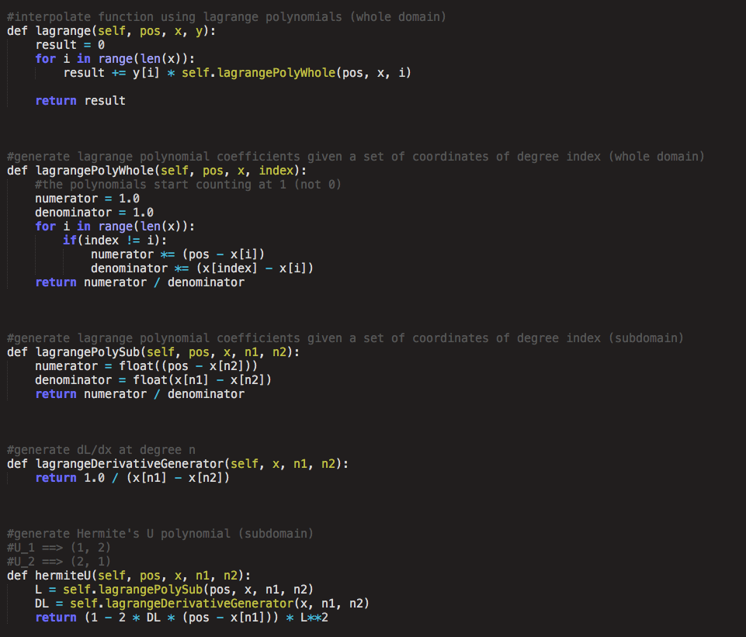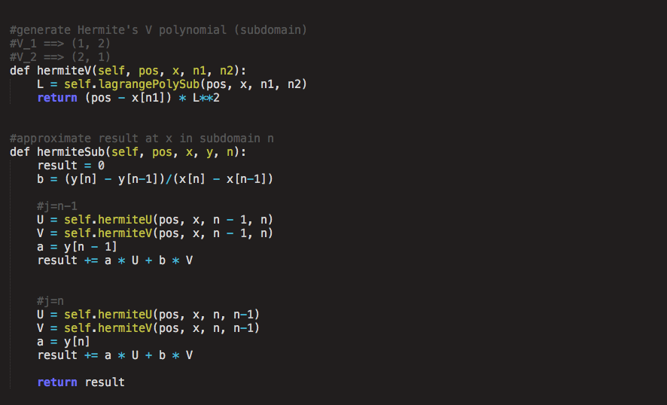

circuit.py (for Question 3)

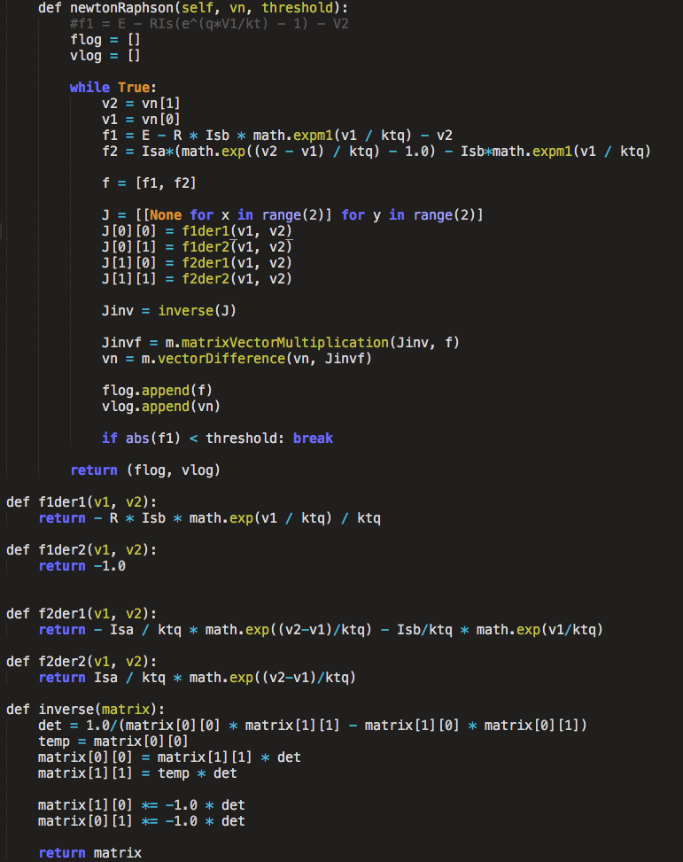

integration.py

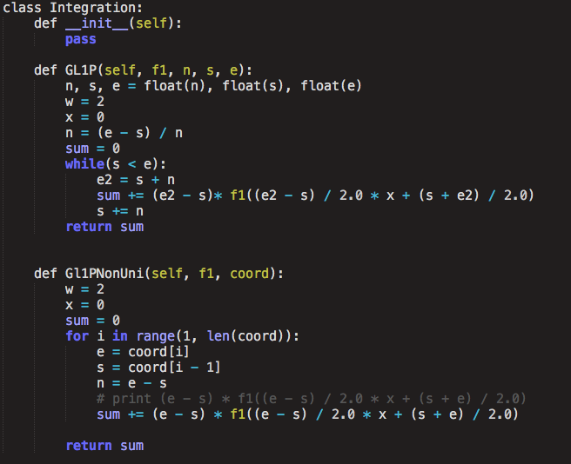

nonlinear.py

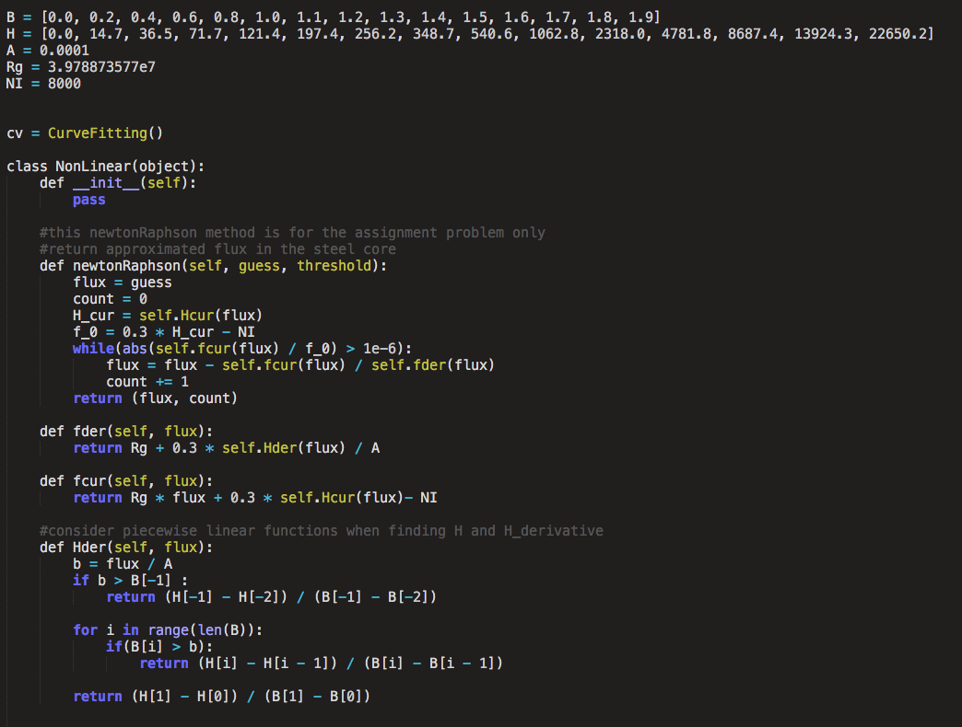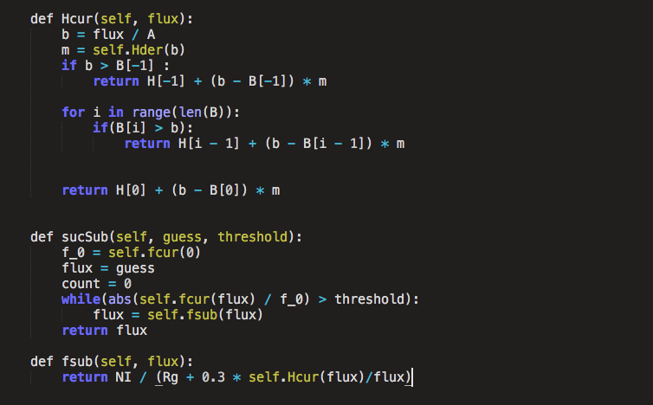

Test file for Question 1

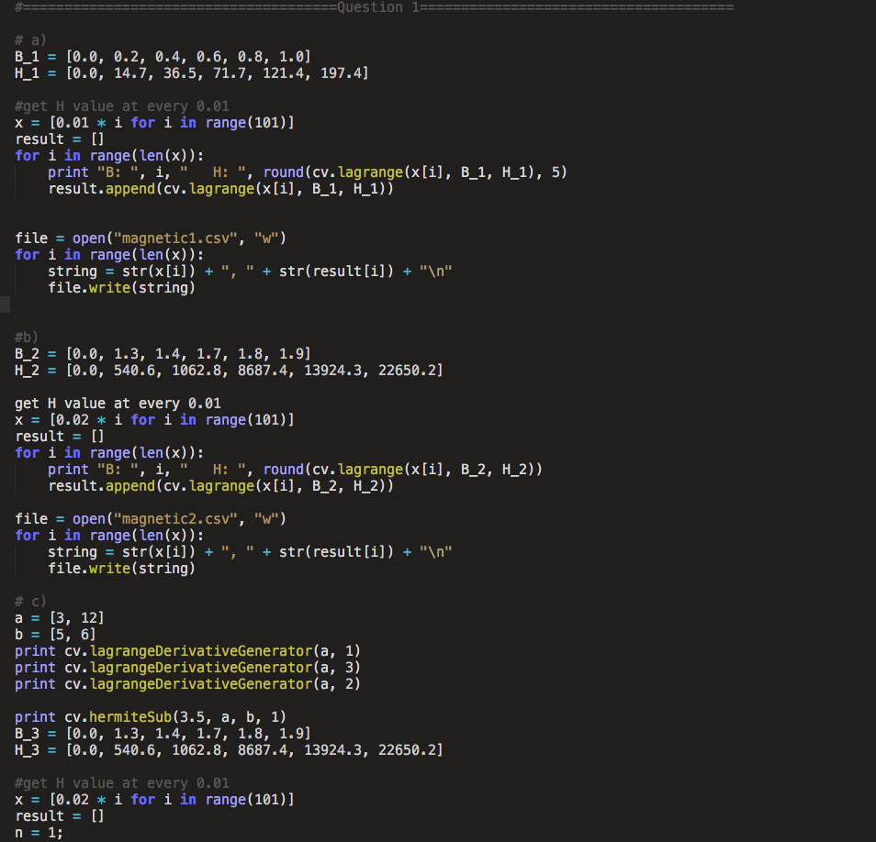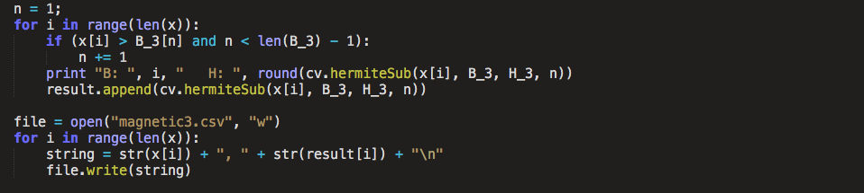

Test file for Question 2

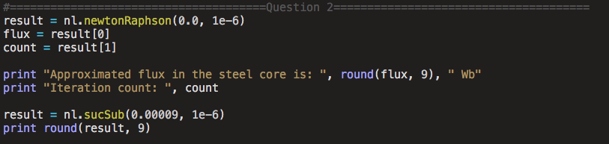

Test file for Question 3

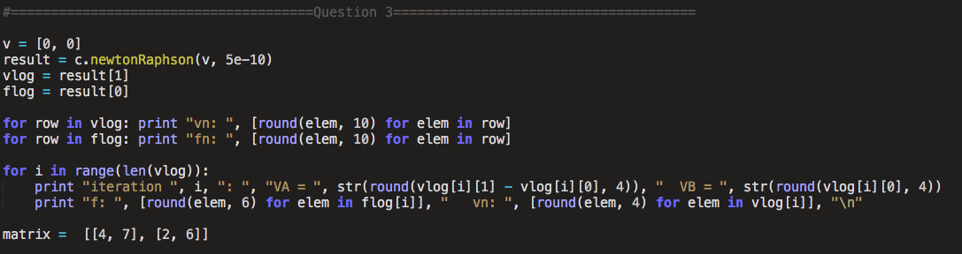

Test file for Question 4

